Beginner Guide to Using Git and GitHub
#Git
– April 15th 2016



What is Git?
Git is a Version Control System (VCS) that keeps track of all the changes to your project files, allowing you to work with your team on the same code while saving you a lot of confusion that tends to happen when multiple people are editing the same files. Git stores every record of every change that you or someone else makes to the project, and this makes keeping track of your progress easy. If you need to look at your old code, or if you need to see what or who modified it – the record is always there.

What is GitHub?
GitHub acts as remote storage for your Git repositories and provides a really neat and simple way for people to collaborate and contribute to development projects. If you are looking for ways to contribute to open source, GitHub is the place to go. If you are new to development, you can use GitHub as a learning tool by analysing popular code repositories.

Let’s Get Started
If you haven’t installed Git yet, follow the instructions here. And remember, using Git does not require having internet connection, since all the files are stored locally.
First, let’s set your identity. Git uses that information for every commit.
- git config --global user.name "Your Name"
- git config --global user.email mail@example.com

Create Repository
The repository is like a container of your project. It holds all the files and information about the project. Most of the git commands are not available outside of the initialized repository.
Note: the name is not important, and all the information about the repository is stored in the .git folder – so you can rename it at all times.
To create new repository, you type this command (new_project is the directory you want to create a repository at):
- git init new_project
You can also take the following steps to create a git repository for your existing project:
- cd my_current_project
- git init
Now that we have a fresh repository for our project, let’s make a project description file:
- echo "To-do list web app, organize and share your to-do's" > README.md
- git add README.md
- git commit -m "Initial Project Commit"
Think of a git commit as saying “okay git, you can save this state of the project and If I will ever need to come back to look at it, I will let you know.” And try to get in the habit of committing changes regularly. Trust me, it will be your lifesaver.
Note: When you add new files to your project, git does not track them, you have to add them to the staging area first as we did above using git add.

ermao@ermao-ThinkPad-W510:~$ pwd
/home/ermao
ermao@ermao-ThinkPad-W510:~$ git --version
git version 2.17.1
ermao@ermao-ThinkPad-W510:~$ git init new_project
Initialized empty Git repository in /home/ermao/new_project/.git/
ermao@ermao-ThinkPad-W510:~$ ls
Desktop eclipse Music Public Videos
Documents eclipse-UbuntuWorkspace- new_project snap
Downloads examples.desktop Pictures Templates
ermao@ermao-ThinkPad-W510:~$ cd new_project
ermao@ermao-ThinkPad-W510:~/new_project$ git config --global user.name "ermao750125"
ermao@ermao-ThinkPad-W510:~/new_project$ git config --global user.email ermao750125@gmail.com
ermao@ermao-ThinkPad-W510:~/new_project$ echo "To-do list web app, organize and share your to-do's" > README.md
ermao@ermao-ThinkPad-W510:~/new_project$ git status
On branch master

No commits yet

Untracked files:
(use "git add <file>..." to include in what will be committed)

README.md

nothing added to commit but untracked files present (use "git add" to track)
ermao@ermao-ThinkPad-W510:~/new_project$ echo "To-do list web app in the second phase, organize and share your to-do's in the second phase" > README_second.md
ermao@ermao-ThinkPad-W510:~/new_project$ git status
On branch master
No commits yet
Untracked files:
(use "git add <file>..." to include in what will be committed)
README.md
README_second.md
nothing added to commit but untracked files present (use "git add" to track)
ermao@ermao-ThinkPad-W510:~/new_project$ git add README.md
ermao@ermao-ThinkPad-W510:~/new_project$ git status
On branch master
No commits yet
Changes to be committed:
(use "git rm --cached <file>..." to unstage)
new file: README.md
Untracked files:
(use "git add <file>..." to include in what will be committed)

README_second.md
ermao@ermao-ThinkPad-W510:~/new_project$ echo "To-do list web app in the third phase, organize and share your to-do's in the third phase" > README_third.md
ermao@ermao-ThinkPad-W510:~/new_project$ git status
On branch master
No commits yet
Changes to be committed:
(use "git rm --cached <file>..." to unstage)
new file: README.md
Untracked files:
(use "git add <file>..." to include in what will be committed)
README_second.md
README_third.md
ermao@ermao-ThinkPad-W510:~/new_project$ git commit -m "Initial Project Commit for the first phase"
[master (root-commit) 6878e78] Initial Project Commit for the first phase
1 file changed, 1 insertion(+)
create mode 100644 README.md
ermao@ermao-ThinkPad-W510:~/new_project$ git status
On branch master
Untracked files:
(use "git add <file>..." to include in what will be committed)

README_second.md
README_third.md

nothing added to commit but untracked files present (use "git add" to track)
ermao@ermao-ThinkPad-W510:~/new_project$ git add README_second.md
ermao@ermao-ThinkPad-W510:~/new_project$ git status
On branch master
Changes to be committed:
(use "git reset HEAD <file>..." to unstage)

new file: README_second.md

Untracked files:
(use "git add <file>..." to include in what will be committed)

README_third.md

ermao@ermao-ThinkPad-W510:~/new_project$ git commit -m "Initial Project Commit for the second phase"
[master 50c8200] Initial Project Commit for the second phase
1 file changed, 1 insertion(+)
create mode 100644 README_second.md
ermao@ermao-ThinkPad-W510:~/new_project$ git status
On branch master
Untracked files:
(use "git add <file>..." to include in what will be committed)

README_third.md

nothing added to commit but untracked files present (use "git add" to track)
ermao@ermao-ThinkPad-W510:~/new_project$ git add .
ermao@ermao-ThinkPad-W510:~/new_project$ git status
On branch master
Changes to be committed:
(use "git reset HEAD <file>..." to unstage)

new file: README_third.md

ermao@ermao-ThinkPad-W510:~/new_project$ git commit -m "Initial Project Commit for the third phase"
[master 7483f87] Initial Project Commit for the third phase
1 file changed, 1 insertion(+)
create mode 100644 README_third.md
ermao@ermao-ThinkPad-W510:~/new_project$ git status
On branch master
nothing to commit, working tree clean
ermao@ermao-ThinkPad-W510:~/new_project$

Staging Area
The staging area stores information and lets you control precisely what will go into your next commit.
git status will show the current version control status about untracked files, and ones that have any possible committable changes.
Try using git status. If you followed what I did, you should get a “working directory clean” message from git. Let’s add some new files to our repo and try again.
- touch index.php style.css script.js
- git status
git status will now show you a list of untracked files, which means if you were to make changes to these files, git will not track them. To test that, let’s modify one of the files.
- echo "<html>" > index.php
- git diff
git diff shows the differences between your working directory and the staging area. But because we haven’t staged the files yet, the output is pretty obvious, and git doesn’t see any changes. Let’s change that by adding files to the staging area.
- git add index.php script.js style.css
- git echo "<head></head></html>" >> index.php
- git diff
As you see now, git knows exactly what was modified in the file, and changes for these files will be tracked at all times. But note that each time you modify a file, it needs to be re-added to the staging area. Think of it as letting git know that you are done with that file, and once the next commit is issued, git can safely save the state of the file. However, if you are done with all of the files and you want to commit changes to all files at once, there’s an option to do it.
ermao@ermao-ThinkPad-W510:~/new_project$ git status
On branch master
nothing to commit, working tree clean
ermao@ermao-ThinkPad-W510:~/new_project$ touch index.php style.css script.js
ermao@ermao-ThinkPad-W510:~/new_project$ git status
On branch master
Untracked files:
(use "git add <file>..." to include in what will be committed)

index.php
script.js
style.css

nothing added to commit but untracked files present (use "git add" to track)
ermao@ermao-ThinkPad-W510:~/new_project$ echo "<html>" > index.php
ermao@ermao-ThinkPad-W510:~/new_project$ git diff
ermao@ermao-ThinkPad-W510:~/new_project$ git add index.php script.js style.css
ermao@ermao-ThinkPad-W510:~/new_project$ git echo "<head></head></html>" >> index.php
git: 'echo' is not a git command. See 'git --help'.

The most similar command is
fetch
ermao@ermao-ThinkPad-W510:~/new_project$ echo "<head></head></html>" >> index.php
ermao@ermao-ThinkPad-W510:~/new_project$ git diff
diff --git a/index.php b/index.php
index 1a18979..b55d393 100644
--- a/index.php
+++ b/index.php
@@ -1 +1,2 @@
<html>
+<head></head></html>
ermao@ermao-ThinkPad-W510:~/new_project$
ermao@ermao-ThinkPad-W510:~/new_project$ git status
On branch master
Changes to be committed:
(use "git reset HEAD <file>..." to unstage)
new file: index.php
new file: script.js
new file: style.css
Changes not staged for commit:
(use "git add <file>..." to update what will be committed)
(use "git checkout -- <file>..." to discard changes in working directory)
modified: index.php

Extra Note: > redirects and overwrites, while >> redirects and appends.
ermao@ermao-ThinkPad-W510:~/new_project$ echo "<head2></head2></html2>" > index.php
ermao@ermao-ThinkPad-W510:~/new_project$ git status
On branch master
Changes to be committed:
(use "git reset HEAD <file>..." to unstage)

new file: index.php
new file: script.js
new file: style.css

Changes not staged for commit:
(use "git add <file>..." to update what will be committed)
(use "git checkout -- <file>..." to discard changes in working directory)

modified: index.php

ermao@ermao-ThinkPad-W510:~/new_project$ git diff
diff --git a/index.php b/index.php
index 1a18979..0218835 100644
--- a/index.php
+++ b/index.php
@@ -1 +1 @@
-<html>
+<head2></head2></html2>

ermao@ermao-ThinkPad-W510:~/new_project$ echo "<head3></head3></html3>" > index.php
ermao@ermao-ThinkPad-W510:~/new_project$ git status
On branch master
Changes to be committed:
(use "git reset HEAD <file>..." to unstage)

new file: index.php
new file: script.js
new file: style.css

Changes not staged for commit:
(use "git add <file>..." to update what will be committed)
(use "git checkout -- <file>..." to discard changes in working directory)

modified: index.php

ermao@ermao-ThinkPad-W510:~/new_project$ git diff
diff --git a/index.php b/index.php
index 1a18979..9474ac0 100644
--- a/index.php
+++ b/index.php
@@ -1 +1 @@
-<html>
+<head3></head3></html3>

This means that if we don’t add the file, no change happen. Only <html> in the file.
-<html>
+<head3></head3></html3>
After add, change can be keeped.
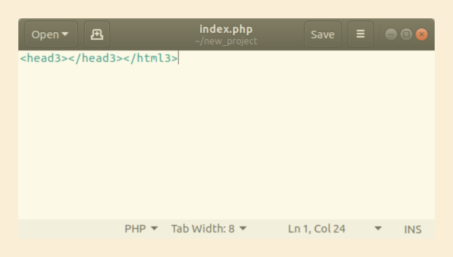
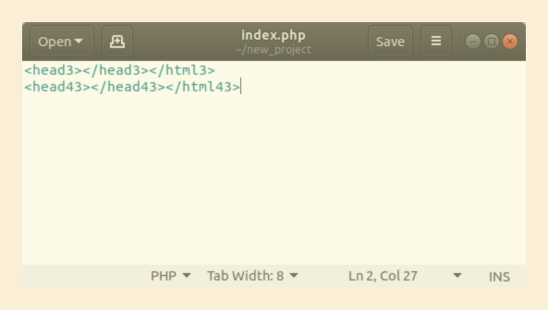

ermao@ermao-ThinkPad-W510:~/new_project$ echo "<head43></head43></html43>" >> index.php
ermao@ermao-ThinkPad-W510:~/new_project$ git diff
diff --git a/index.php b/index.php
index 1a18979..88d0d3d 100644
--- a/index.php
+++ b/index.php
@@ -1 +1,2 @@
-<html>
+<head3></head3></html3>
+<head43></head43></html43>
ermao@ermao-ThinkPad-W510:~/new_project$

ermao@ermao-ThinkPad-W510:~/new_project$ echo "<head543></head543></html543>" > index.php
ermao@ermao-ThinkPad-W510:~/new_project$ git diff
diff --git a/index.php b/index.php
index 1a18979..bb74cff 100644
--- a/index.php
+++ b/index.php
@@ -1 +1 @@
-<html>
+<head543></head543></html543>
ermao@ermao-ThinkPad-W510:~/new_project$
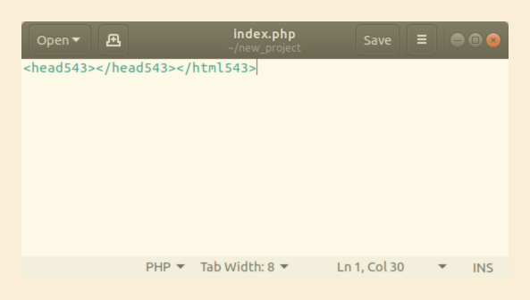
ermao@ermao-ThinkPad-W510:~/new_project$ git commit -m"this is for checking change before and after add"
[master 421d511] this is for checking change before and after add
3 files changed, 1 insertion(+)
create mode 100644 index.php
create mode 100644 script.js
create mode 100644 style.css
ermao@ermao-ThinkPad-W510:~/new_project$ git status
On branch master
Changes not staged for commit:
(use "git add <file>..." to update what will be committed)
(use "git checkout -- <file>..." to discard changes in working directory)

modified: index.php

no changes added to commit (use "git add" and/or "git commit -a")
ermao@ermao-ThinkPad-W510:~/new_project$ echo "<head43></head43></html43>" >> index.php
ermao@ermao-ThinkPad-W510:~/new_project$

this means before add the old file not change, keep to be <html>, then change as order. But not keep the change before it is added.

- git commit -m "Initial project files"
Now think which state of index.php we have committed, the one with HTML tags or the empty file? If it’s not clear for you, this should clear this out for you:
- git commit -a -m "Initial project files + HTML Markup"
See the difference by using the option -a , where you indicate that all files should be committed.
Note: Be aware that option -a only applies for the files that are tracked by git. If you have untracked files, you still have to add them to the staging area before committing.
To review your previous commits, use git log, and it will display all the commits you have made so far. To go back to a certain state of the project, use the git checkout command and provide the commit identifier.
- git log
- git checkout 4ea35ab9d43a8d6521bace280ae24477f799f132

ermao@ermao-ThinkPad-W510:~/new_project$ git log
commit 421d51164a81fa38587d8b66a425033df74a1214 (HEAD -> master)
Author: ermao750125 <ermao750125@gmail.com>
Date: Thu Oct 25 12:27:03 2018 -0400

this is for checking change before and after add

commit 7483f87edeed0bfc5ca480598f1205c09ed181ac
Author: ermao750125 <ermao750125@gmail.com>
Date: Thu Oct 25 10:33:22 2018 -0400

Initial Project Commit for the third phase

commit 50c820024e5024d5f16a33de78dffe81588bafe4
Author: ermao750125 <ermao750125@gmail.com>
Date: Thu Oct 25 10:32:31 2018 -0400

Initial Project Commit for the second phase

commit 6878e78cc3ea84ed58dbd661bc347d0e05a6b762
Author: ermao750125 <ermao750125@gmail.com>
Date: Thu Oct 25 10:31:23 2018 -0400

Initial Project Commit for the first phase
:...skipping...
commit 421d51164a81fa38587d8b66a425033df74a1214 (HEAD -> master)
Author: ermao750125 <ermao750125@gmail.com>
Date: Thu Oct 25 12:27:03 2018 -0400

this is for checking change before and after add

commit 7483f87edeed0bfc5ca480598f1205c09ed181ac
Author: ermao750125 <ermao750125@gmail.com>
Date: Thu Oct 25 10:33:22 2018 -0400

Initial Project Commit for the third phase

commit 50c820024e5024d5f16a33de78dffe81588bafe4
Author: ermao750125 <ermao750125@gmail.com>
Date: Thu Oct 25 10:32:31 2018 -0400

Initial Project Commit for the second phase

commit 6878e78cc3ea84ed58dbd661bc347d0e05a6b762
Author: ermao750125 <ermao750125@gmail.com>
Date: Thu Oct 25 10:31:23 2018 -0400

Initial Project Commit for the first phase
However, you actually don’t need to use the full length of identifier. Usually the first 5 characters are enough:
- git checkout 4ea35
Once you check out, your project directory and its content will be exactly the same as it was once the commit was issued. To go back to your production branch, use:
- git checkout master

Branching
Think of branching as creating a separate copy of a certain state of a project. Let’s say you are working on your website and you would like to add a new feature. To do that, just branch out your latest version and add the feature. Once you are happy with the result, you can go ahead and merge it.
- git branch feature_x
- git checkout feature_x
- echo "function(){...}" > script.js
- git commit -a -m "Function x done"
Note: You won’t see any changes in the master branch until you merge them.
To get a list of branches, use git branch.
To merge two branches together, go to the branch you want it to be merged with. In our case, let’s use master branch.
- git checkout master
- git merge feature_x
All the changes and timelines are now merged. But sometimes you might encounter merge conflicts git doesn’t know how to resolve. Let’s create the merge conflict by editing the same line on both branches:
- git checkout feature_x
- echo "body{background-color:red;}" > style.css
- git add style.css
- git commit -m "BG color change"
- git checkout master
- echo "body{background-color:blue;}" > style.css
- git add style.css
- git commit -m "BG color change"
- git merge feature_x
ermao@ermao-ThinkPad-W510:~/new_project$ git checkout feature_x
error: pathspec 'feature_x' did not match any file(s) known to git.
ermao@ermao-ThinkPad-W510:~/new_project$ git branch feature_x
ermao@ermao-ThinkPad-W510:~/new_project$ git checkout feature_x
M index.php
Switched to branch 'feature_x'
ermao@ermao-ThinkPad-W510:~/new_project$ echo "body{background-color:red;}" > style.css
ermao@ermao-ThinkPad-W510:~/new_project$ git add style.css
ermao@ermao-ThinkPad-W510:~/new_project$ git commit -m "BG color change"
[feature_x 1ed7519] BG color change
1 file changed, 1 insertion(+)
ermao@ermao-ThinkPad-W510:~/new_project$ git checkout master
M index.php
Switched to branch 'master'
ermao@ermao-ThinkPad-W510:~/new_project$ echo "body{background-color:blue;}" > style.css
ermao@ermao-ThinkPad-W510:~/new_project$ git add style.css
ermao@ermao-ThinkPad-W510:~/new_project$ git commit -m "BG color change"
[master 1b05f97] BG color change
1 file changed, 1 insertion(+)
ermao@ermao-ThinkPad-W510:~/new_project$ git merge feature_x
Auto-merging style.css
CONFLICT (content): Merge conflict in style.css
Automatic merge failed; fix conflicts and then commit the result.

The simplest way to resolve merge conflict is just edit the conflicted file. Upon opening the conflicted file, you will see that git made some changes to the file :
<<<<<<< HEAD
body{background-color:red;}
=======
body{background-color:blue;}
>>>>>>> feature_x
However, if you decide to fix it, git will accept it as a valid solution.
HEAD - latest commit in the current branch
==== - separator between the two versions
<<<< - start of the conflict
>>>> - end of the conflict
Once you have decided which color you want your background to be and removed the conflict:
- git add style.css
- git commit -m ""
When we merge branches, git automatically generates a commit message, so once the issue is resolved it still knows that this file is a part of the merge process, so you can leave the -m option empty and git will generate a message for you.
ermao@ermao-ThinkPad-W510:~/new_project$ git log
commit 1b05f9736bf157db1e3591cc20a14e18f1ed9d9a (HEAD -> master)
Author: ermao750125 <ermao750125@gmail.com>
Date: Thu Oct 25 14:11:30 2018 -0400

BG color change

commit 421d51164a81fa38587d8b66a425033df74a1214
Author: ermao750125 <ermao750125@gmail.com>
Date: Thu Oct 25 12:27:03 2018 -0400

this is for checking change before and after add

commit 7483f87edeed0bfc5ca480598f1205c09ed181ac
Author: ermao750125 <ermao750125@gmail.com>
Date: Thu Oct 25 10:33:22 2018 -0400

Initial Project Commit for the third phase

commit 50c820024e5024d5f16a33de78dffe81588bafe4
Author: ermao750125 <ermao750125@gmail.com>
Date: Thu Oct 25 10:32:31 2018 -0400

Initial Project Commit for the second phase

commit 6878e78cc3ea84ed58dbd661bc347d0e05a6b762
Author: ermao750125 <ermao750125@gmail.com>
Date: Thu Oct 25 10:31:23 2018 -0400

Initial Project Commit for the first phase

Branching model
You don’t need to go to deep on this right now, but just know that it’s there. When you will start using git for you daily projects, be aware that you can use this successful branching model by Vincent Driessen. It offers a nice development/release structure and is quite easy to comprehend.
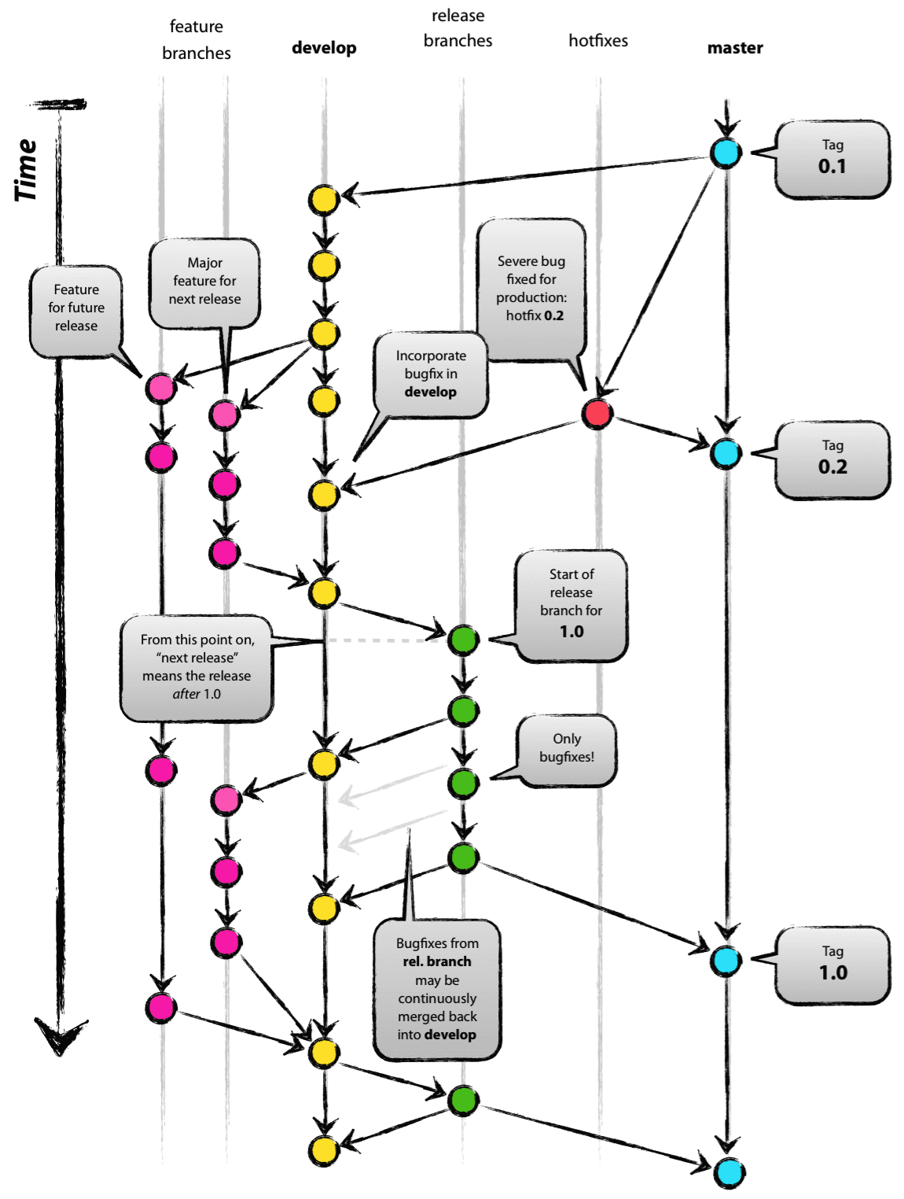
Original blog post: http://nvie.com/posts/a-succesful-git-branching-model

Remote Repository (GitHub)
We will be using GitHub as our remote repository, but it can be anywhere. You can share it on your local network or have a server for it. It is completely optional to have it, but if you are planning to share your project or collaborate with other people, it’s a good idea to have one. GitHub offers two different ways to host your repository: private or public. If you want to host it privately, there are paid subscriptions for that, but as long as you don’t need it, you can use GitHub for free.

Creating a New Repository
There are few ways to create a GitHub repository. You can do it directly at GitHub – on the top right corner, click on the plus sign and chose new repository. Alternatively, you can create a repository with a command-line using GitHub’s API and cURL. You can also download a desktop application for managing your repositories.

Directly at GitHub:
There are a few options you should look at when creating a new repository – privacy settings, license, and git ignore file.
If you are a true Open Source admirer – generally an MIT license should be good to go, but if you are still not sure and want to read more about it, go here. Also, you have an option for the .gitignore file to be added to your repository, and it does exactly what it sounds like it would do – it ignores files and does not track them. If you have some sort of personal configuration files for your text editor and they are not really part of the project, you might want to have that in your ignore file.
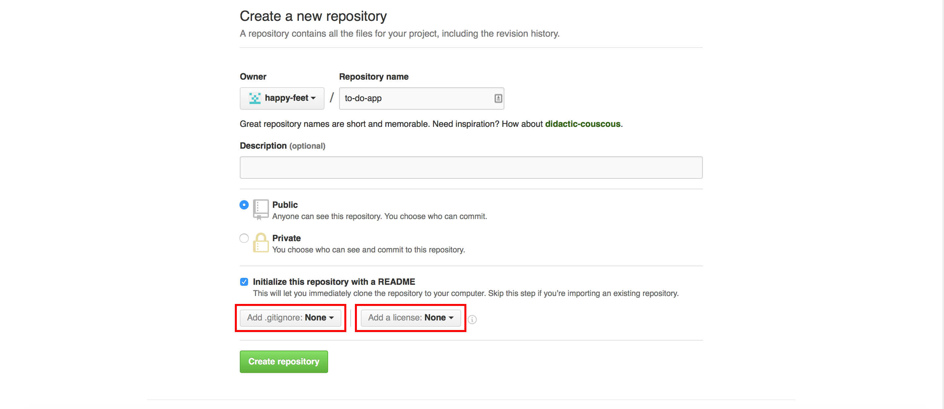

Command-Line:
The GitHub API uses default settings if a user doesn’t provide any parameters. If you want to change any of these, you can easily do that by adding extra parameters between brackets.
curl -u 'YOUR_GIT_HUB_ID' https://api.github.com/user/repos -d '{"name":"REPOSITORY_NAME",description":"DESCRIPTION"}'
Let’s say you want to make a repository private:
curl -u 'YOUR_GIT_HUB_ID' https://api.github.com/user/repos -d '{"name":"REPOSITORY_NAME","description":"DESCRIPTION","private":true}'
Here’s the complete list of attributes you can use when creating a new repo:
If you are planning to create a lot of repositories through the command line, I suggest making shell function, so you don’t have to type the whole thing out. I will cover that at the end of the tutorial.
Once you have a repository ready, let’s push our local project to GitHub.
- git remote add origin https://github.com/YOUR_USERNAME/PROJECT_NAME.git
- git push -u origin master
And that’s it. All your files are now accessible via GitHub.
Now let’s say you want to work on your project, but you don’t have access to your project files. The only thing you need to do is to clone the repository and you are good to go:
- git clone https://github.com/YOUR-USERNAME/YOUR-REPOSITORY
If you forgot the name of your repository, you can always find it on GitHub:
Once you are done for the day and all commits are ready to be pushed, use git push and that’s it! You have updated your repository.
- git push -u origin master

Contributing
You can find a project you want to contribute to by using GitHub’s search feature. You can search for projects in your favourite language, or you can narrow down your search results by using search qualifiers. When you find a project you want to work on, you should familiarise yourself with the guidelines on getting involved. This can usually be found in the CONTRIBUTING.md file, and it’s a good idea to check the commit log too, as it helps you get familiar with the structure and the vocabulary of the commit messages for that project.
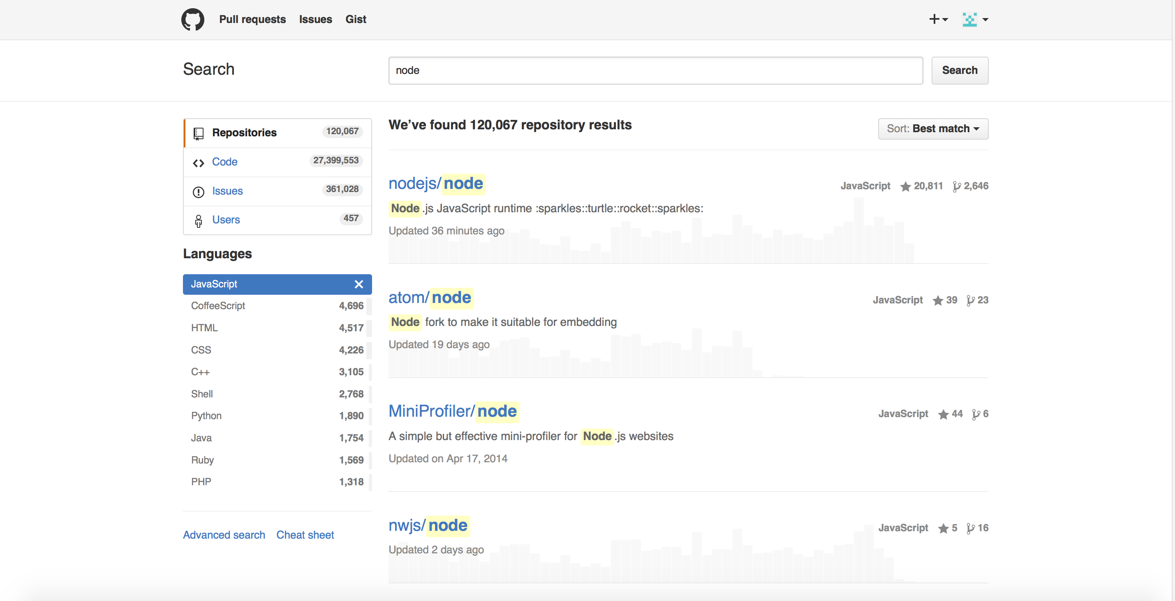
Here are the most important parts to know when you are about to contribute to the project:
- Fork – Makes your own copy of the project and allows you to freely work on it without affecting the original project. Fork a project if you are planning to contribute to it, or if you just want to use the project as a starting point for yours.
- Issues – Keeps track of bugs, enhancements and future feature suggestions. This section is generally used as a discussion board.
- Commits – This is where your git log goes, as it contains all of the commit messages
- New pull request – If you have solved an issue or added a feature and you want to offer your code to be part of the project.
- CONTRIBUTING.md – Specific guidelines for how one can contribute to the project.
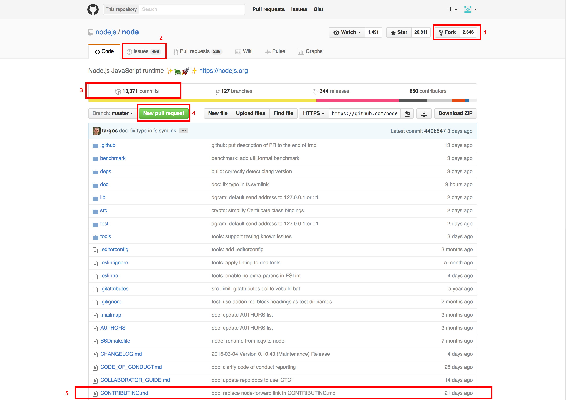
Here’s the general flow you have to go through when you are contributing:
Step 1: Fork the project:
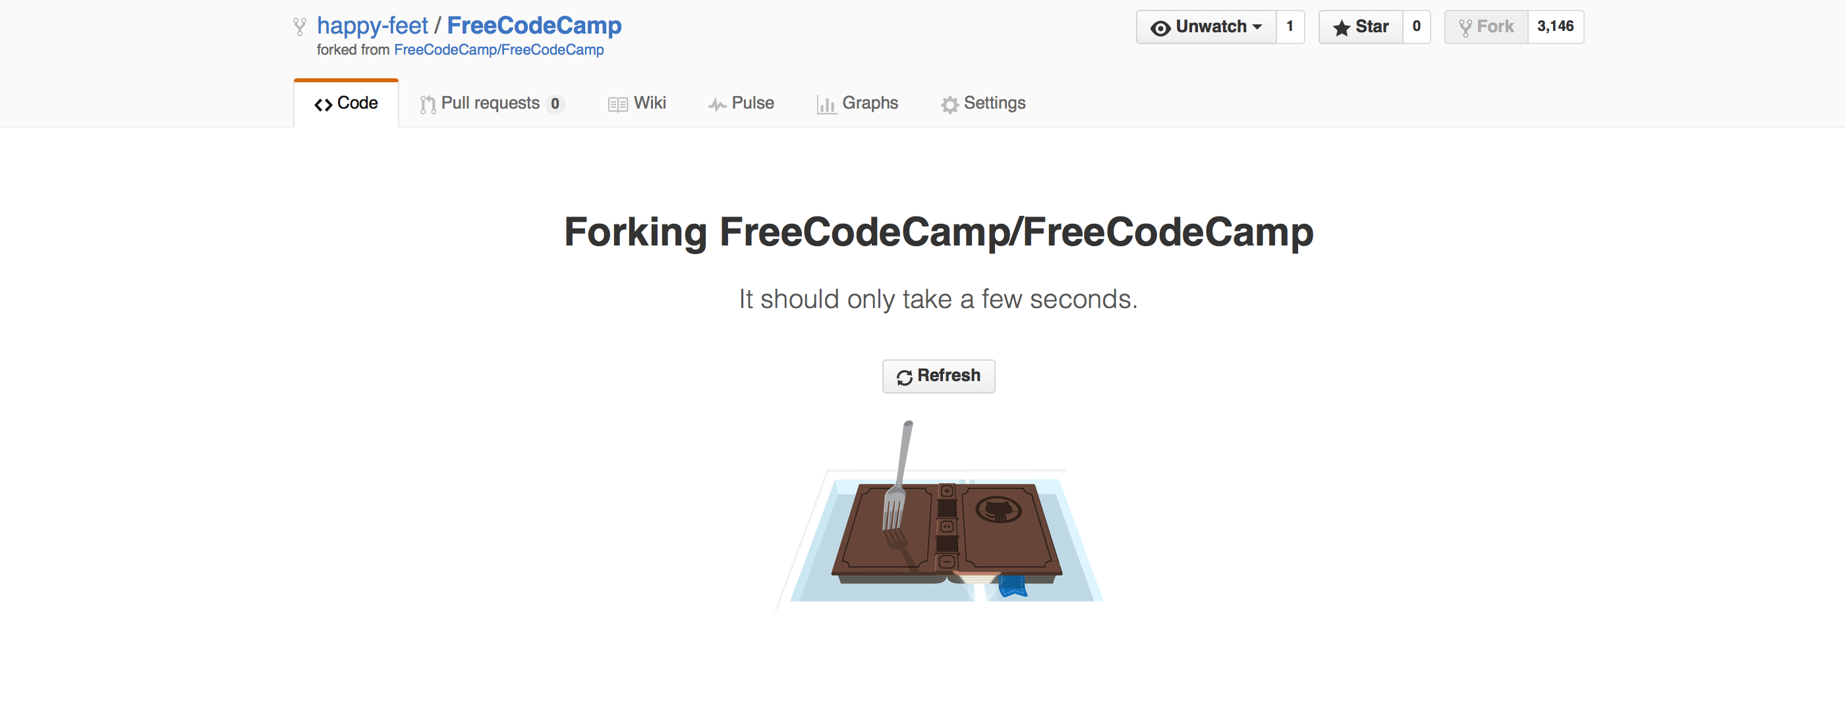
Step 2: Clone repository to your local machine
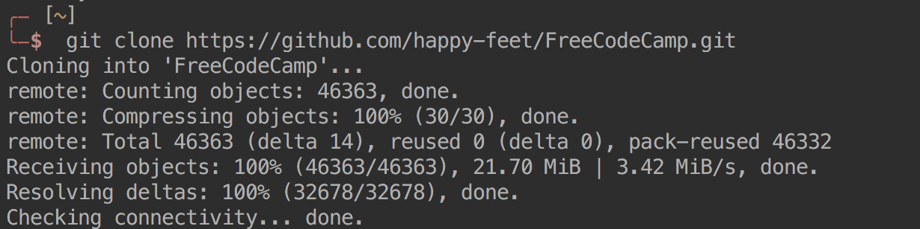
When you clone the repository, its remote location is set to your forked project. If some new changes are made to the original project and you try to pull them, git won’t see them. So to keep up with the original repository you need to set up upstream.
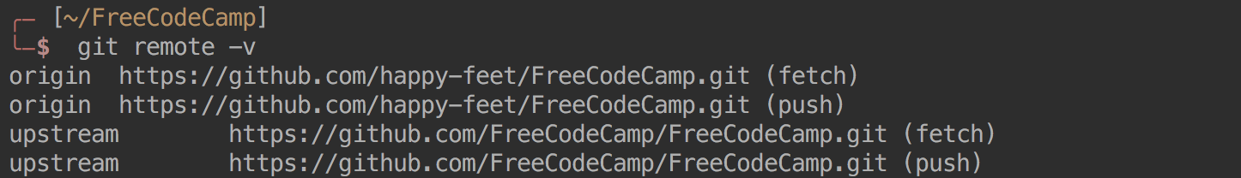
Now you have access to both repositories.
To sync a fork with original repository, use git fetch.

Step 3: Create a feature/fix branch
Once you have the project files ready, let’s make feature branch that has some logical meaning to it.
Command-Line:

At GitHub:
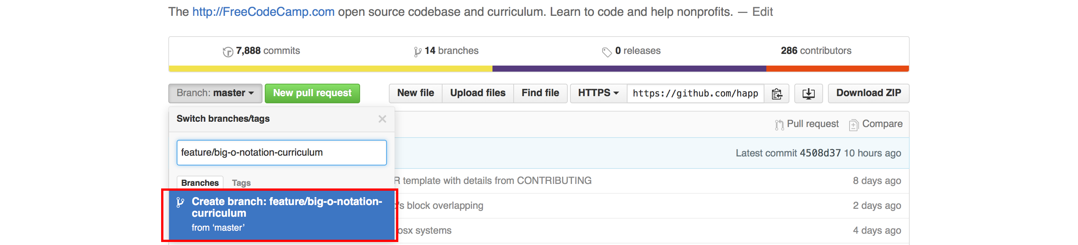

Step 4: Push back the good stuff
After you made your changes and made a specific commit to them, go ahead and push it back to GitHub.
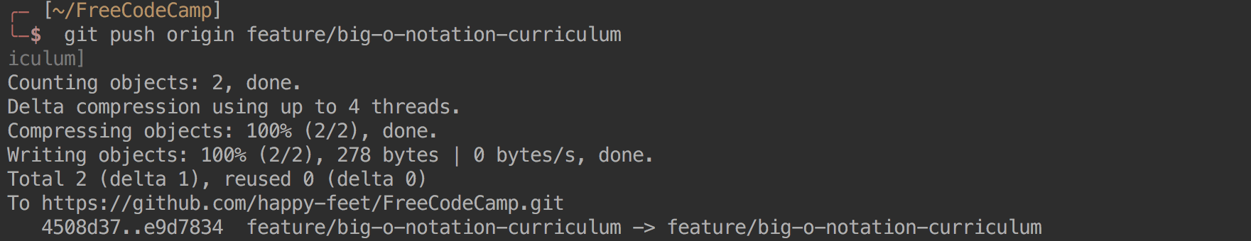

Step 5: Create a pull request
Finally, choose your feature branch and compare it to your base branch. When you are ready, click the create pull request button.
Congrats! You have made your first pull request! Now just sit back and wait for someone to look at your code. If your pull request has been declined, don’t worry. That happens to everyone – just make any requested changes to your code, and open another pull request.

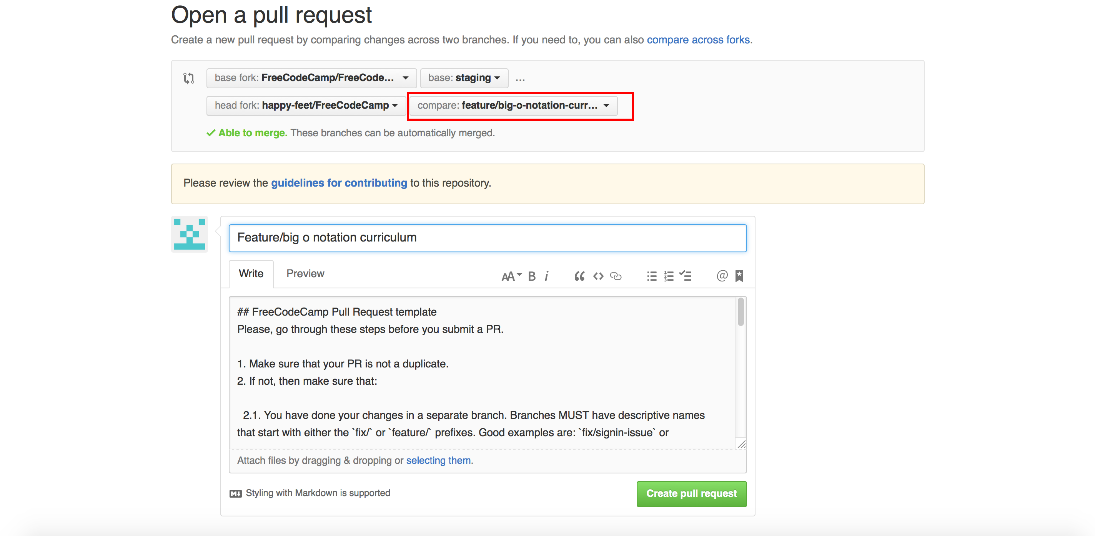

Step 6: Get a beer and be proud of yourself
Shell Function
If you are not sure what shell you are using, you can find it out by typing echo $SHELL in your terminal window. Then, based on what you see, you will need to add this function to your startup shell script file. If you are using bash, usually it’s found at ~/.bashrc, for zsh users ~/.zshrc. If you are using some other shell, please google the location of your startup file and note that you might need to modify the following function:
github-new() {

repo_name=$1

while [ "$repo_name" = "" ]
do
echo "Enter name of a new repository:"
read repo_name
done

github_user="YOUR-USERNAME"

while [ "$github_user" = "" ]
do
echo "Enter your GitHub username:"
read github_user
done

curl -u "$github_user" https://api.github.com/user/repos -d'{"name":"'$repo_name'"}'

}
Save it, restart the terminal, and create repository with:
github-new NAME_OF_REPOSITORY

Conclusion
I haven’t covered everything there is to know, but it should be more than enough to get you started. If you followed through the whole article, you should now know how to use basic git commands and how to get your projects online. In addition, you now know how to make contributions to open source projects. I also encourage you to do so, as it’s a really powerful way to get yourself out there and receive feedback from experts. Most importantly, don’t get discouraged if you feel confused – it’s a lot of information for one day, and it’s natural that you don’t remember or completely comprehend some parts just keep practising and come back for the reference if you get stuck.

About the Author:

Tomas Laurinavicius is a web, user interface and user experience designer who has been focusing on usable and visually aesthetic web and mobile app design for over 5 years.
ermao@ermao-ThinkPad-W510:~$ pwd
/home/ermao
ermao@ermao-ThinkPad-W510:~$ git --version
git version 2.17.1
ermao@ermao-ThinkPad-W510:~$ git init new_project
Initialized empty Git repository in /home/ermao/new_project/.git/
ermao@ermao-ThinkPad-W510:~$ ls
Desktop eclipse Music Public Videos
Documents eclipse-UbuntuWorkspace- new_project snap
Downloads examples.desktop Pictures Templates
ermao@ermao-ThinkPad-W510:~$ cd new_project
ermao@ermao-ThinkPad-W510:~/new_project$ git config --global user.name "ermao750125"
ermao@ermao-ThinkPad-W510:~/new_project$ git config --global user.email ermao750125@gmail.com
ermao@ermao-ThinkPad-W510:~/new_project$ echo "To-do list web app, organize and share your to-do's" > README.md
ermao@ermao-ThinkPad-W510:~/new_project$ git status
On branch master

No commits yet

Untracked files:
(use "git add <file>..." to include in what will be committed)

README.md

nothing added to commit but untracked files present (use "git add" to track)
ermao@ermao-ThinkPad-W510:~/new_project$ echo "To-do list web app in the second phase, organize and share your to-do's in the second phase" > README_second.md
ermao@ermao-ThinkPad-W510:~/new_project$ git status
On branch master

No commits yet

Untracked files:
(use "git add <file>..." to include in what will be committed)

README.md
README_second.md

nothing added to commit but untracked files present (use "git add" to track)
ermao@ermao-ThinkPad-W510:~/new_project$ git add README.md
ermao@ermao-ThinkPad-W510:~/new_project$ git status
On branch master

No commits yet

Changes to be committed:
(use "git rm --cached <file>..." to unstage)

new file: README.md

Untracked files:
(use "git add <file>..." to include in what will be committed)

README_second.md

ermao@ermao-ThinkPad-W510:~/new_project$ echo "To-do list web app in the third phase, organize and share your to-do's in the third phase" > README_third.md
ermao@ermao-ThinkPad-W510:~/new_project$ git status
On branch master

No commits yet

Changes to be committed:
(use "git rm --cached <file>..." to unstage)

new file: README.md

Untracked files:
(use "git add <file>..." to include in what will be committed)

README_second.md
README_third.md

ermao@ermao-ThinkPad-W510:~/new_project$ git commit -m "Initial Project Commit for the first phase"
[master (root-commit) 6878e78] Initial Project Commit for the first phase
1 file changed, 1 insertion(+)
create mode 100644 README.md
ermao@ermao-ThinkPad-W510:~/new_project$ git status
On branch master
Untracked files:
(use "git add <file>..." to include in what will be committed)

README_second.md
README_third.md

nothing added to commit but untracked files present (use "git add" to track)
ermao@ermao-ThinkPad-W510:~/new_project$ git add README_second.md
ermao@ermao-ThinkPad-W510:~/new_project$ git status
On branch master
Changes to be committed:
(use "git reset HEAD <file>..." to unstage)

new file: README_second.md

Untracked files:
(use "git add <file>..." to include in what will be committed)

README_third.md

ermao@ermao-ThinkPad-W510:~/new_project$ git commit -m "Initial Project Commit for the second phase"
[master 50c8200] Initial Project Commit for the second phase
1 file changed, 1 insertion(+)
create mode 100644 README_second.md
ermao@ermao-ThinkPad-W510:~/new_project$ git status
On branch master
Untracked files:
(use "git add <file>..." to include in what will be committed)

README_third.md

nothing added to commit but untracked files present (use "git add" to track)
ermao@ermao-ThinkPad-W510:~/new_project$ git add .
ermao@ermao-ThinkPad-W510:~/new_project$ git status
On branch master
Changes to be committed:
(use "git reset HEAD <file>..." to unstage)

new file: README_third.md

ermao@ermao-ThinkPad-W510:~/new_project$ git commit -m "Initial Project Commit for the third phase"
[master 7483f87] Initial Project Commit for the third phase
1 file changed, 1 insertion(+)
create mode 100644 README_third.md
ermao@ermao-ThinkPad-W510:~/new_project$ git status
On branch master
nothing to commit, working tree clean
ermao@ermao-ThinkPad-W510:~/new_project$ touch index.php style.css script.js
ermao@ermao-ThinkPad-W510:~/new_project$ git status
On branch master
Untracked files:
(use "git add <file>..." to include in what will be committed)

index.php
script.js
style.css

nothing added to commit but untracked files present (use "git add" to track)
ermao@ermao-ThinkPad-W510:~/new_project$ echo "<html>" > index.php
ermao@ermao-ThinkPad-W510:~/new_project$ git diff
ermao@ermao-ThinkPad-W510:~/new_project$ git add index.php script.js style.css
ermao@ermao-ThinkPad-W510:~/new_project$ git echo "<head></head></html>" >> index.php
git: 'echo' is not a git command. See 'git --help'.

The most similar command is
fetch
ermao@ermao-ThinkPad-W510:~/new_project$ echo "<head></head></html>" >> index.php
ermao@ermao-ThinkPad-W510:~/new_project$ git diff
diff --git a/index.php b/index.php
index 1a18979..b55d393 100644
--- a/index.php
+++ b/index.php
@@ -1 +1,2 @@
<html>
+<head></head></html>
ermao@ermao-ThinkPad-W510:~/new_project$ git status
On branch master
Changes to be committed:
(use "git reset HEAD <file>..." to unstage)

new file: index.php
new file: script.js
new file: style.css

Changes not staged for commit:
(use "git add <file>..." to update what will be committed)
(use "git checkout -- <file>..." to discard changes in working directory)

modified: index.php

ermao@ermao-ThinkPad-W510:~/new_project$ echo "<head2></head2></html2>" > index.php
ermao@ermao-ThinkPad-W510:~/new_project$ git status
On branch master
Changes to be committed:
(use "git reset HEAD <file>..." to unstage)

new file: index.php
new file: script.js
new file: style.css

Changes not staged for commit:
(use "git add <file>..." to update what will be committed)
(use "git checkout -- <file>..." to discard changes in working directory)

modified: index.php

ermao@ermao-ThinkPad-W510:~/new_project$ git diff
diff --git a/index.php b/index.php
index 1a18979..0218835 100644
--- a/index.php
+++ b/index.php
@@ -1 +1 @@
-<html>
+<head2></head2></html2>
ermao@ermao-ThinkPad-W510:~/new_project$ echo "<head3></head3></html3>" > index.php
ermao@ermao-ThinkPad-W510:~/new_project$ git status
On branch master
Changes to be committed:
(use "git reset HEAD <file>..." to unstage)

new file: index.php
new file: script.js
new file: style.css

Changes not staged for commit:
(use "git add <file>..." to update what will be committed)
(use "git checkout -- <file>..." to discard changes in working directory)

modified: index.php

ermao@ermao-ThinkPad-W510:~/new_project$ git diff
diff --git a/index.php b/index.php
index 1a18979..9474ac0 100644
--- a/index.php
+++ b/index.php
@@ -1 +1 @@
-<html>
+<head3></head3></html3>
ermao@ermao-ThinkPad-W510:~/new_project$ echo "<head43></head43></html43>" >> index.php
ermao@ermao-ThinkPad-W510:~/new_project$ git diff
diff --git a/index.php b/index.php
index 1a18979..88d0d3d 100644
--- a/index.php
+++ b/index.php
@@ -1 +1,2 @@
-<html>
+<head3></head3></html3>
+<head43></head43></html43>
ermao@ermao-ThinkPad-W510:~/new_project$ echo "<head543></head543></html543>" > index.php
ermao@ermao-ThinkPad-W510:~/new_project$ git diff
diff --git a/index.php b/index.php
index 1a18979..bb74cff 100644
--- a/index.php
+++ b/index.php
@@ -1 +1 @@
-<html>
+<head543></head543></html543>
ermao@ermao-ThinkPad-W510:~/new_project$ git status
On branch master
Changes to be committed:
(use "git reset HEAD <file>..." to unstage)

new file: index.php
new file: script.js
new file: style.css

Changes not staged for commit:
(use "git add <file>..." to update what will be committed)
(use "git checkout -- <file>..." to discard changes in working directory)

modified: index.php

ermao@ermao-ThinkPad-W510:~/new_project$ git add .
ermao@ermao-ThinkPad-W510:~/new_project$ echo "<head43></head43></html43>" >> index.php
ermao@ermao-ThinkPad-W510:~/new_project$ git diff
diff --git a/index.php b/index.php
index bb74cff..61ffbd4 100644
--- a/index.php
+++ b/index.php
@@ -1 +1,2 @@
<head543></head543></html543>
+<head43></head43></html43>
ermao@ermao-ThinkPad-W510:~/new_project$ echo "<head3></head3></html3>" > index.php
ermao@ermao-ThinkPad-W510:~/new_project$ git diff
diff --git a/index.php b/index.php
index bb74cff..9474ac0 100644
--- a/index.php
+++ b/index.php
@@ -1 +1 @@
-<head543></head543></html543>
+<head3></head3></html3>
ermao@ermao-ThinkPad-W510:~/new_project$ git commit -m"this is for checking change before and after add"
[master 421d511] this is for checking change before and after add
3 files changed, 1 insertion(+)
create mode 100644 index.php
create mode 100644 script.js
create mode 100644 style.css
ermao@ermao-ThinkPad-W510:~/new_project$ git status
On branch master
Changes not staged for commit:
(use "git add <file>..." to update what will be committed)
(use "git checkout -- <file>..." to discard changes in working directory)

modified: index.php

no changes added to commit (use "git add" and/or "git commit -a")
ermao@ermao-ThinkPad-W510:~/new_project$ echo "<head43></head43></html43>" >> index.php
ermao@ermao-ThinkPad-W510:~/new_project$ git log
commit 421d51164a81fa38587d8b66a425033df74a1214 (HEAD -> master)
Author: ermao750125 <ermao750125@gmail.com>
Date: Thu Oct 25 12:27:03 2018 -0400

this is for checking change before and after add

commit 7483f87edeed0bfc5ca480598f1205c09ed181ac
Author: ermao750125 <ermao750125@gmail.com>
Date: Thu Oct 25 10:33:22 2018 -0400

Initial Project Commit for the third phase

commit 50c820024e5024d5f16a33de78dffe81588bafe4
Author: ermao750125 <ermao750125@gmail.com>
Date: Thu Oct 25 10:32:31 2018 -0400

Initial Project Commit for the second phase

commit 6878e78cc3ea84ed58dbd661bc347d0e05a6b762
Author: ermao750125 <ermao750125@gmail.com>
Date: Thu Oct 25 10:31:23 2018 -0400

Initial Project Commit for the first phase
:...skipping...
commit 421d51164a81fa38587d8b66a425033df74a1214 (HEAD -> master)
Author: ermao750125 <ermao750125@gmail.com>
Date: Thu Oct 25 12:27:03 2018 -0400

this is for checking change before and after add

commit 7483f87edeed0bfc5ca480598f1205c09ed181ac
Author: ermao750125 <ermao750125@gmail.com>
Date: Thu Oct 25 10:33:22 2018 -0400

Initial Project Commit for the third phase

commit 50c820024e5024d5f16a33de78dffe81588bafe4
Author: ermao750125 <ermao750125@gmail.com>
Date: Thu Oct 25 10:32:31 2018 -0400

Initial Project Commit for the second phase

commit 6878e78cc3ea84ed58dbd661bc347d0e05a6b762
Author: ermao750125 <ermao750125@gmail.com>
Date: Thu Oct 25 10:31:23 2018 -0400

Initial Project Commit for the first phase
~
ermao@ermao-ThinkPad-W510:~/new_project$ git checkout 7483f87edeed0bfc5
error: Your local changes to the following files would be overwritten by checkout:
index.php
Please commit your changes or stash them before you switch branches.
Aborting
ermao@ermao-ThinkPad-W510:~/new_project$ git checkout master
M index.php
Already on 'master'
ermao@ermao-ThinkPad-W510:~/new_project$ git checkout feature_x
error: pathspec 'feature_x' did not match any file(s) known to git.
ermao@ermao-ThinkPad-W510:~/new_project$ git branch feature_x
ermao@ermao-ThinkPad-W510:~/new_project$ git checkout feature_x
M index.php
Switched to branch 'feature_x'
ermao@ermao-ThinkPad-W510:~/new_project$ echo "body{background-color:red;}" > style.css
ermao@ermao-ThinkPad-W510:~/new_project$ git add style.css
ermao@ermao-ThinkPad-W510:~/new_project$ git commit -m "BG color change"
[feature_x 1ed7519] BG color change
1 file changed, 1 insertion(+)
ermao@ermao-ThinkPad-W510:~/new_project$ git checkout master
M index.php
Switched to branch 'master'
ermao@ermao-ThinkPad-W510:~/new_project$ echo "body{background-color:blue;}" > style.css
ermao@ermao-ThinkPad-W510:~/new_project$ git add style.css
ermao@ermao-ThinkPad-W510:~/new_project$ git commit -m "BG color change"
[master 1b05f97] BG color change
1 file changed, 1 insertion(+)
ermao@ermao-ThinkPad-W510:~/new_project$ git merge feature_x
Auto-merging style.css
CONFLICT (content): Merge conflict in style.css
Automatic merge failed; fix conflicts and then commit the result.
ermao@ermao-ThinkPad-W510:~/new_project$ git add style.css
ermao@ermao-ThinkPad-W510:~/new_project$ git commit -m ""
Aborting commit due to empty commit message.
ermao@ermao-ThinkPad-W510:~/new_project$ git log
commit 1b05f9736bf157db1e3591cc20a14e18f1ed9d9a (HEAD -> master)
Author: ermao750125 <ermao750125@gmail.com>
Date: Thu Oct 25 14:11:30 2018 -0400

BG color change

commit 421d51164a81fa38587d8b66a425033df74a1214
Author: ermao750125 <ermao750125@gmail.com>
Date: Thu Oct 25 12:27:03 2018 -0400

this is for checking change before and after add

commit 7483f87edeed0bfc5ca480598f1205c09ed181ac
Author: ermao750125 <ermao750125@gmail.com>
Date: Thu Oct 25 10:33:22 2018 -0400

Initial Project Commit for the third phase

commit 50c820024e5024d5f16a33de78dffe81588bafe4
Author: ermao750125 <ermao750125@gmail.com>
Date: Thu Oct 25 10:32:31 2018 -0400

Initial Project Commit for the second phase

commit 6878e78cc3ea84ed58dbd661bc347d0e05a6b762
Author: ermao750125 <ermao750125@gmail.com>
Date: Thu Oct 25 10:31:23 2018 -0400

Initial Project Commit for the first phase
ermao@ermao-ThinkPad-W510:~/new_project$ git remote add origin https://github.com/ermao750125/to-do-app.git
ermao@ermao-ThinkPad-W510:~/new_project$ git push -u origin master
Username for 'https://github.com': ermao750125
Password for 'https://ermao750125@github.com':
To https://github.com/ermao750125/to-do-app.git
! [rejected] master -> master (fetch first)
error: failed to push some refs to 'https://github.com/ermao750125/to-do-app.git'
hint: Updates were rejected because the remote contains work that you do
hint: not have locally. This is usually caused by another repository pushing
hint: to the same ref. You may want to first integrate the remote changes
hint: (e.g., 'git pull ...') before pushing again.
hint: See the 'Note about fast-forwards' in 'git push --help' for details.
ermao@ermao-ThinkPad-W510:~/new_project$

kPad-W510:~/new_project$ git merge feature_x
bash: kPad-W510:~/new_project$: No such file or directory
ermao@ermao-ThinkPad-W510:~/new_project$ Auto-merging style.css
Auto-merging: command not found
ermao@ermao-ThinkPad-W510:~/new_project$ CONFLICT (content): Merge conflict in style.css
bash: syntax error near unexpected token `content'
ermao@ermao-ThinkPad-W510:~/new_project$ Automatic merge failed; fix conflicts and then commit the result.
Automatic: command not found

Command 'fix' not found, did you mean:

command 'six' from deb gambc
command 'fio' from deb fio
command 'mix' from deb elixir
command 'fis' from deb redboot-tools
command 'fid' from deb id-utils
command 'gfix' from deb firebird3.0-utils
command 'fim' from deb fim
command 'fox' from deb objcryst-fox
command 'flix' from deb epix
command 'fax' from deb efax
command 'efix' from deb efax
command 'fmix' from deb embassy-phylip

Try: sudo apt install <deb name>

ermao@ermao-ThinkPad-W510:~/new_project$ ermao@ermao-ThinkPad-W510:~/new_project$ git add style.css
bash: ermao@ermao-ThinkPad-W510:~/new_project$: No such file or directory
ermao@ermao-ThinkPad-W510:~/new_project$ ermao@ermao-ThinkPad-W510:~/new_project$ git commit -m ""
bash: ermao@ermao-ThinkPad-W510:~/new_project$: No such file or directory
ermao@ermao-ThinkPad-W510:~/new_project$ Aborting commit due to empty commit message.
Aborting: command not found
ermao@ermao-ThinkPad-W510:~/new_project$ ermao@ermao-ThinkPad-W510:~/new_project$ git log
bash: ermao@ermao-ThinkPad-W510:~/new_project$: No such file or directory
ermao@ermao-ThinkPad-W510:~/new_project$ commit 1b05f9736bf157db1e3591cc20a14e18f1ed9d9a (HEAD -> master)
bash: syntax error near unexpected token `('
ermao@ermao-ThinkPad-W510:~/new_project$ Author: ermao750125 <ermao750125@gmail.com>
bash: syntax error near unexpected token `newline'
ermao@ermao-ThinkPad-W510:~/new_project$ Date: Thu Oct 25 14:11:30 2018 -0400
Date:: command not found
ermao@ermao-ThinkPad-W510:~/new_project$
ermao@ermao-ThinkPad-W510:~/new_project$ BG color change
BG: command not found
ermao@ermao-ThinkPad-W510:~/new_project$
ermao@ermao-ThinkPad-W510:~/new_project$ commit 421d51164a81fa38587d8b66a425033df74a1214
commit: command not found
ermao@ermao-ThinkPad-W510:~/new_project$ Author: ermao750125 <ermao750125@gmail.com>
bash: syntax error near unexpected token `newline'
ermao@ermao-ThinkPad-W510:~/new_project$ Date: Thu Oct 25 12:27:03 2018 -0400
Date:: command not found
ermao@ermao-ThinkPad-W510:~/new_project$
ermao@ermao-ThinkPad-W510:~/new_project$ this is for checking change before and after add

Command 'this' not found, did you mean:

command 'thin' from deb thin

Try: sudo apt install <deb name>

ermao@ermao-ThinkPad-W510:~/new_project$
ermao@ermao-ThinkPad-W510:~/new_project$ commit 7483f87edeed0bfc5ca480598f1205c09ed181ac
commit: command not found
ermao@ermao-ThinkPad-W510:~/new_project$ Author: ermao750125 <ermao750125@gmail.com>
bash: syntax error near unexpected token `newline'
ermao@ermao-ThinkPad-W510:~/new_project$ Date: Thu Oct 25 10:33:22 2018 -0400
Date:: command not found
ermao@ermao-ThinkPad-W510:~/new_project$
ermao@ermao-ThinkPad-W510:~/new_project$ Initial Project Commit for the third phase
Initial: command not found
ermao@ermao-ThinkPad-W510:~/new_project$
ermao@ermao-ThinkPad-W510:~/new_project$ commit 50c820024e5024d5f16a33de78dffe81588bafe4
commit: command not found
ermao@ermao-ThinkPad-W510:~/new_project$ Author: ermao750125 <ermao750125@gmail.com>
bash: syntax error near unexpected token `newline'
ermao@ermao-ThinkPad-W510:~/new_project$ Date: Thu Oct 25 10:32:31 2018 -0400
Date:: command not found
ermao@ermao-ThinkPad-W510:~/new_project$
ermao@ermao-ThinkPad-W510:~/new_project$ Initial Project Commit for the second phase
Initial: command not found
ermao@ermao-ThinkPad-W510:~/new_project$
ermao@ermao-ThinkPad-W510:~/new_project$ kPad-W510:~/new_project$ git merge feature_x
bash: kPad-W510:~/new_project$: No such file or directory
ermao@ermao-ThinkPad-W510:~/new_project$ Auto-merging style.css
Auto-merging: command not found
ermao@ermao-ThinkPad-W510:~/new_project$ CONFLICT (content): Merge conflict in style.css
bash: syntax error near unexpected token `content'
ermao@ermao-ThinkPad-W510:~/new_project$ Automatic merge failed; fix conflicts and then commit the result.
Automatic: command not found

Command 'fix' not found, did you mean:

command 'fio' from deb fio
command 'efix' from deb efax
command 'fox' from deb objcryst-fox
command 'fis' from deb redboot-tools
command 'gfix' from deb firebird3.0-utils
command 'fmix' from deb embassy-phylip
command 'six' from deb gambc
command 'fax' from deb efax
command 'mix' from deb elixir
command 'flix' from deb epix
command 'fid' from deb id-utils
command 'fim' from deb fim

Try: sudo apt install <deb name>

ermao@ermao-ThinkPad-W510:~/new_project$ ermao@ermao-ThinkPad-W510:~/new_project$ git add style.css
bash: ermao@ermao-ThinkPad-W510:~/new_project$: No such file or directory
ermao@ermao-ThinkPad-W510:~/new_project$ ermao@ermao-ThinkPad-W510:~/new_project$ git commit -m ""
bash: ermao@ermao-ThinkPad-W510:~/new_project$: No such file or directory
ermao@ermao-ThinkPad-W510:~/new_project$ Aborting commit due to empty commit message.
Aborting: command not found
ermao@ermao-ThinkPad-W510:~/new_project$ ermao@ermao-ThinkPad-W510:~/new_project$ git log
bash: ermao@ermao-ThinkPad-W510:~/new_project$: No such file or directory
ermao@ermao-ThinkPad-W510:~/new_project$ commit 1b05f9736bf157db1e3591cc20a14e18f1ed9d9a (HEAD -> master)
bash: syntax error near unexpected token `('
ermao@ermao-ThinkPad-W510:~/new_project$ Author: ermao750125 <ermao750125@gmail.com>
bash: syntax error near unexpected token `newline'
ermao@ermao-ThinkPad-W510:~/new_project$ Date: Thu Oct 25 14:11:30 2018 -0400
Date:: command not found
ermao@ermao-ThinkPad-W510:~/new_project$
ermao@ermao-ThinkPad-W510:~/new_project$ BG color change
BG: command not found
ermao@ermao-ThinkPad-W510:~/new_project$
ermao@ermao-ThinkPad-W510:~/new_project$ commit 421d51164a81fa38587d8b66a425033df74a1214
commit: command not found
ermao@ermao-ThinkPad-W510:~/new_project$ Author: ermao750125 <ermao750125@gmail.com>
bash: syntax error near unexpected token `newline'
ermao@ermao-ThinkPad-W510:~/new_project$ Date: Thu Oct 25 12:27:03 2018 -0400
Date:: command not found
ermao@ermao-ThinkPad-W510:~/new_project$
ermao@ermao-ThinkPad-W510:~/new_project$ this is for checking change before and after add

Command 'this' not found, did you mean:

command 'thin' from deb thin

Try: sudo apt install <deb name>

ermao@ermao-ThinkPad-W510:~/new_project$
ermao@ermao-ThinkPad-W510:~/new_project$ commit 7483f87edeed0bfc5ca480598f1205c09ed181ac
commit: command not found
ermao@ermao-ThinkPad-W510:~/new_project$ Author: ermao750125 <ermao750125@gmail.com>
bash: syntax error near unexpected token `newline'
ermao@ermao-ThinkPad-W510:~/new_project$ Date: Thu Oct 25 10:33:22 2018 -0400
Date:: command not found
ermao@ermao-ThinkPad-W510:~/new_project$
ermao@ermao-ThinkPad-W510:~/new_project$ Initial Project Commit for the third phase
Initial: command not found
ermao@ermao-ThinkPad-W510:~/new_project$
ermao@ermao-ThinkPad-W510:~/new_project$ commit 50c820024e5024d5f16a33de78dffe81588bafe4
commit: command not found
ermao@ermao-ThinkPad-W510:~/new_project$ Author: ermao750125 <ermao750125@gmail.com>
bash: syntax error near unexpected token `newline'
ermao@ermao-ThinkPad-W510:~/new_project$ Date: Thu Oct 25 10:32:31 2018 -0400
Date:: command not found
ermao@ermao-ThinkPad-W510:~/new_project$
ermao@ermao-ThinkPad-W510:~/new_project$ Initial Project Commit for the second phase
Initial: command not found
ermao@ermao-ThinkPad-W510:~/new_project$
ermao@ermao-ThinkPad-W510:~/new_project$

